Owner
Pet Name
Species Feline
Breed DSH
Sex
Age

Assay: SNAP FeLV/FIV

Result:
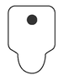

How to interpret your results:
